Student’s Name
Professor’s Name
Course
Date of Submission
Japan South Korea Trade Dispute of August 28th 2019
Japan and South Korea have been trading partners for several years. They have traded in a variety of goods and services which has seen both of their economies grow significantly. The trade between the two countries have raked in millions of dollars and this has been enhanced by the mutual bilateral relationship that the countries have established between them. This, however, came to a sudden halt on August 28^{th,} 2019 when Japan removed South Korea from its list of most trusted trading partners (BBC News 1). This is an action that has brought a lot of consequences in terms of trading between the two countries and the rest of the world. The global market is currently connected and thus the decision of Japan is something that is bound to cause a lot of repercussions in the global economy. Japan South Korea is an international event covered by various media organizations and information manipulated to advance the interests of the market players.
Analysis
The Japan South Korea trade dispute is known out of the fact that it was covered in great length by both the national and international media. The two countries form a strong pillar in the global market and thus any slight action by any of the countries is bound to attract a lot of media coverage. This event was covered in the whole world with countries beaming the headline of the removal of South Korea as one of the trusted trade partners of Japan (Bremmer 1).
The image below shows South Koreans participating in a rally to denounce Japan's new trade restrictions https://time.com/5691631/japan-south-korea-trade-war/
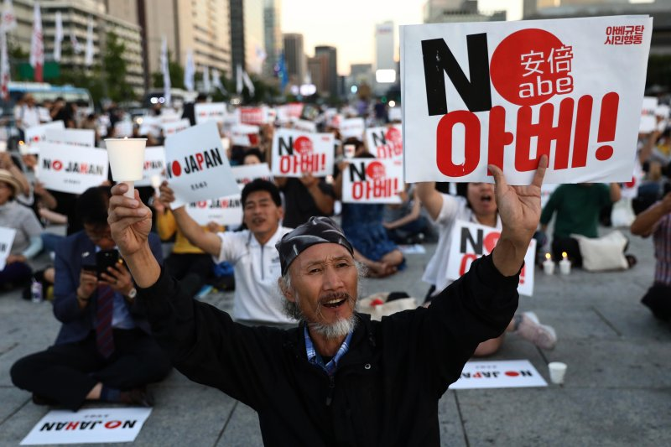
The extensive media coverage enabled most of the countries to be aware of the dispute and strategize accordingly in order to benefit from the fall out between the two partners. The information regarding the issue was manipulated in various countries as most of them sought to position themselves for the opportunities that may be present. There was heightened manipulation of facts to depict a gleaming picture of the dispute. This was also intended to fuel the animosity that was present between the two countries and block any hopes of the countries agreeing to work together again in the future.
Several players were affected by the trade dispute between the two countries. Most of the business people in the two countries and those that depend on them were also severely affected by the action of Japan. This is in the sense that it had become more difficult for them to acquire technology-related contracts and products due to the action committed by Japan. The degrading of South Korea from the white list of traders meant that manufacturers must apply for the approval of each technology-related contracts rather than the simple checks that were being granted to the country as a preferential trade partner (Cutler, 23). This is something that has made it difficult for business people to engage in trade as the approval process tends to take longer time which in turn affects their business. The government has also been affected as there are more stringent regulations which in turn hampers the undertaking of trade between the two countries. Most of the governments seek to ease the process of doing business with its partners and thus, the removal of South Korea has brought a lot of difficulties in conducting business as compared to the previous times.
The rhetorical triangle applies in this case as most of the media organizations that covered the dispute used the aspect of the rhetorical triangle in deep length. This was carried out by the use of ethos to build trust among the people on the worsening condition of the trade dispute (Grant, 33). The media sources wrote with much confidence and proficiency the details regarding the dispute which as then sold to the public. The information contained there was much convincing and this led to most of the people and government believing that the trade dispute was really bad and this was justified by the action of Japan to remove South Korea from the list. Media sources also strived to ensure that they appeal to the members of the public and the governments at large by depicting various images of the dispute. This is something that was intended to capture the thought and imaginations of the public and thus be able to relate to the situation at hand. This was also manifested through the arguments that were advanced in relation to the logical reasoning of the public members in regard to the dispute. This is an important factor as the government can apply logic and thus be aware of what is needed to be done in order to benefit from the opportunities that will be there.
The media and the government in large are the people who keep secrets regarding the trade dispute. This is due to the fact that most of the media sources seek to enhance the position of their countries in terms of trade and thus will be able to use any opportunity to provide information that will benefit their country. They therefore in most cases withhold some of the critical information regarding the dispute and only release those that will worsen the situation and in turn benefit their countries. The Japanese and the South Korean government also keep secrets in order to prevent the public from knowing the full extent of the trade dispute (Pandey16). This is done in order not arouse tensions among the business people in regards to their future. They are promised that things are being sorted out even though this may not be the case in reality. This is a method that the government uses to maintain optimism among the public and prevent a crisis building up.
The dispute on a global level presents a challenge to most countries that in one way or the other depends on the two countries involved. They are forced to adjust to certain extents the level of trading that they had and the expected revenues from it (Bremmer 1). https://time.com/5691631/japan-south-korea-trade-war/
Countries also seek to position themselves into being considered as trusted partners by Japan and this brings about a number of negotiation attempts. This is due to the benefits that are associated with being in the list of trusted partners (Sohn 268). Manipulation of information is a critical aspect as it leads to most people believing the information that is shared and thus commit themselves to certain actions. These actions are meant to ensure that they protect themselves from the consequences of the trade dispute or in other cases to benefit from it.
Conclusion
The action of Japan removing South Korea from its list of trusted trading partners is one that is bound to have a lot of impact on the economic scene. The restrictions that have been imposed are likely to affect to a great extent the manner in which businesses are carried out as the approval process may take longer than expected. This is going to affect the shipment of trading goods and thus contribute to huge loses among traders. The bilateral relationship between the two countries is something that is also going to be affected. Media sources need to present information as it is rather than withholding certain aspects of it which in turn leads to the mass consumption of lies by the citizens. Most of the public members depend on the media to give them accurate information and thus the failure to do so brings a lot of consequences to the public and the government.

Works Cited
Cutler, Wendy, et al. "TRADE IN TROUBLE." (2019).
Grant, Arthur J. "Ethos, Pathos and Logos: Rhetorical Fixes for a
Pandey, Indu. "Tigers on the prowl: south Korea, japan, and the futility of symbolic disputes." Harvard International Review 40.2 (2019): 14-17.
Sohn, Yul. "Japan and South Korea: The Identity-Security-Economy Nexus in a Turbulent Relationship." Japan and Asia’s Contested Order. Palgrave Macmillan, Singapore, 2019. 261-277.
BBC News. South Korea and Japan feud explained. (2019). https://www.bbc.com/news/world-asia-49330531
Bremmer, Ian. Why the Japan South Korea trade war is worrying for the world. (2019). https://time.com/5691631/japan-south-korea-trade-war/

